***Digital to Physical***

***-Ben Miller***

1. The game Premise:

The premise presented was to turn an already existing digital game into a physical board game, and the game created was to be themed around the game “Shadow of Mordor”, and was to be made into a table top game which would be playable by between 2 and 4 different players.

1. Rules and mechanics:

To play the game each player would start off by rolling a dice where the player with the highest number would go first, and lowest would go last. Players then take it turns to roll a dice and they can move up to that number (or less) and take control of an orc on the space they finish on. Players can move in any direction on the board and once an orc has been claimed, that orc can no longer be taken by other players. Each orc has their own card and the aim of the game is to have as many orcs as possible (higher orcs are worth more, such as captains and warlords). Players can also receive passive cards to help them and boost them in the game. The game is concluded after 7 turns, and the winner is then decided.

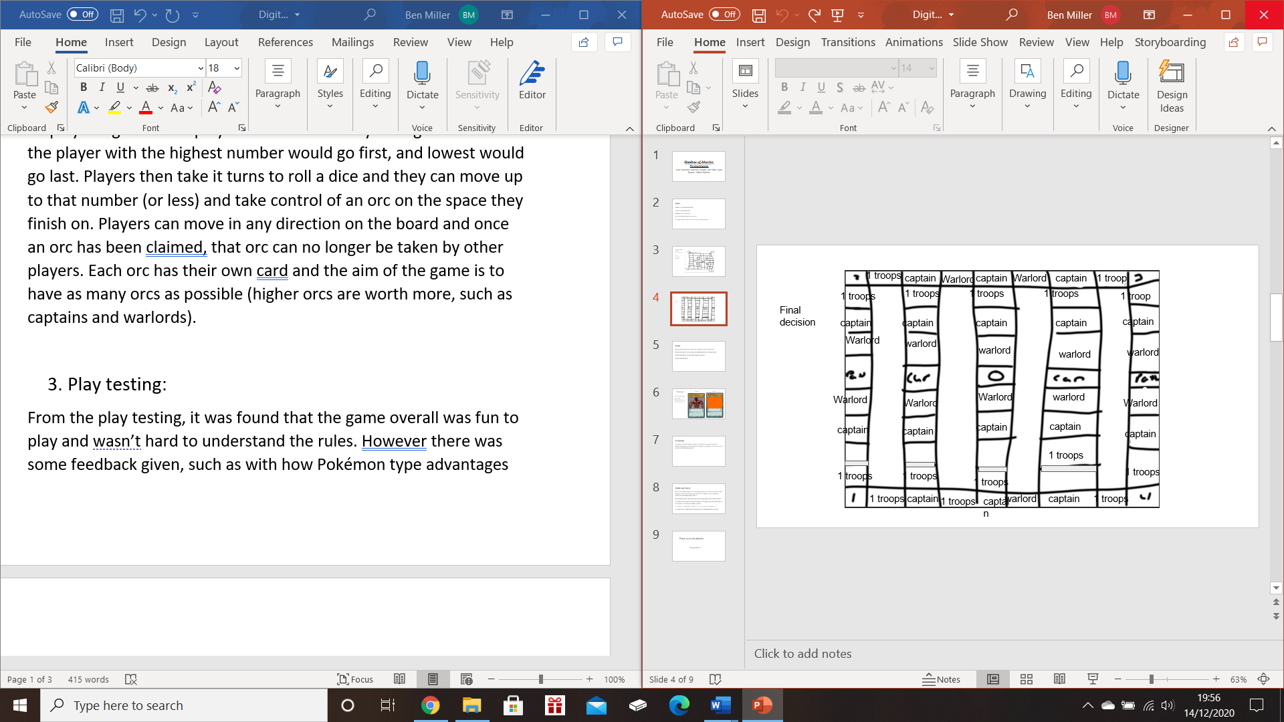

Figure 1: An example of the board

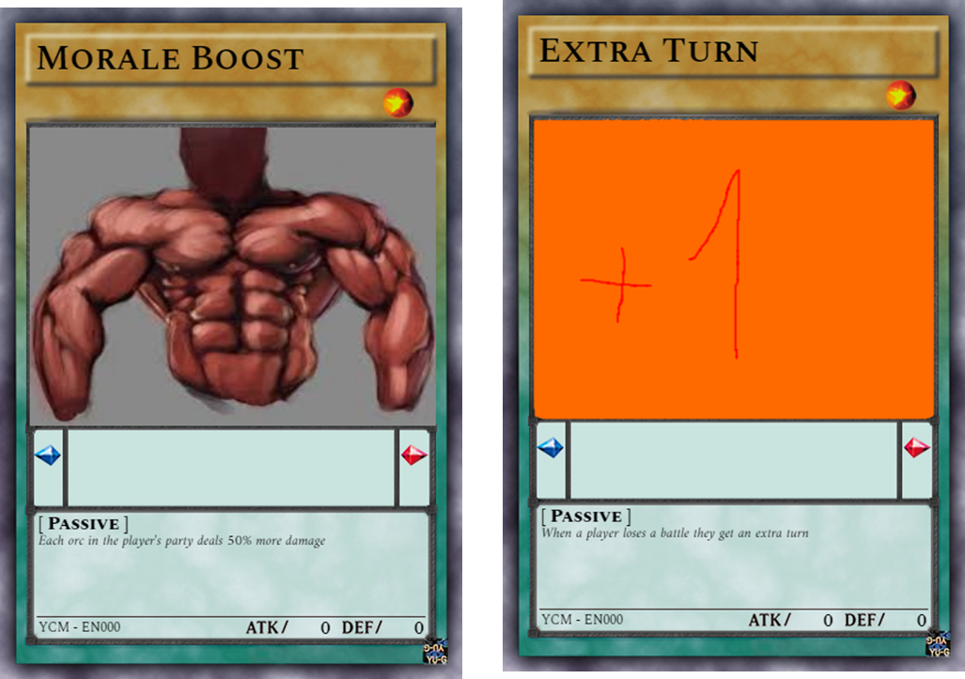

Figure 2: Examples of passive cards within the game

1. Battle mechanics:

Battles are fought using orcs and each player puts in orcs until one player decides that they do not wish to expend any more orcs. Captain orcs are worth three regular orcs and warlords are worth 5.

Once a battle begins each player rolls a dice until a player rolls a higher number.

The winner is the player that has the highest roll. A player can only roll as high as the amount of orcs they are willing to gamble.

1-20 orcs = 1-2 on the die, 21-30 = 3, 31- 40 = 4, 41-50 = 5 and 51+ = 6.

If a player loses a battle they are returned to the starting point on the board.

1. Play testing:

The team did not manage to do any external play testing due to time constraints, but did manage to complete some internal playtesting within the team. From the playtesting, the team found that the game is playable and fun. However to begin with the team found that the first player had an unfair advantage, so the team fixed this by making the board bigger, this then made the game fair in giving any player a chance of winning.

1. Problem solving in teams:

The team worked well in solving problems which may not have been discovered if the team was smaller, showing that team work is the best when trying to discover smaller or bugger problems.

1. What was done well:

What was done well in the end was that the team successfully managed to come together to create a game that was not only fun but also playable.

Team members:

Ben

Brennon

Spas

Callum